HR Login Page:
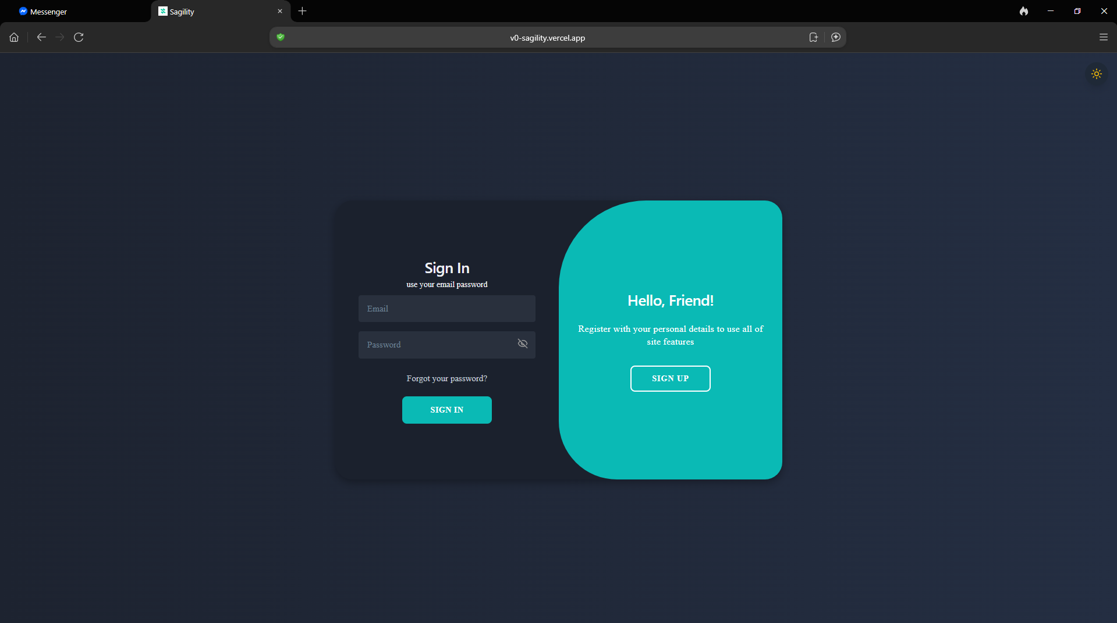
Accessing an HR Employee account requires administrative authorization. An administrator will request your email address and issue your password. In this role, your primary responsibility is to guide job applicants and notify them of missing requirements, serving as the key liaison between applicants and administration.

Pending Applications Page:
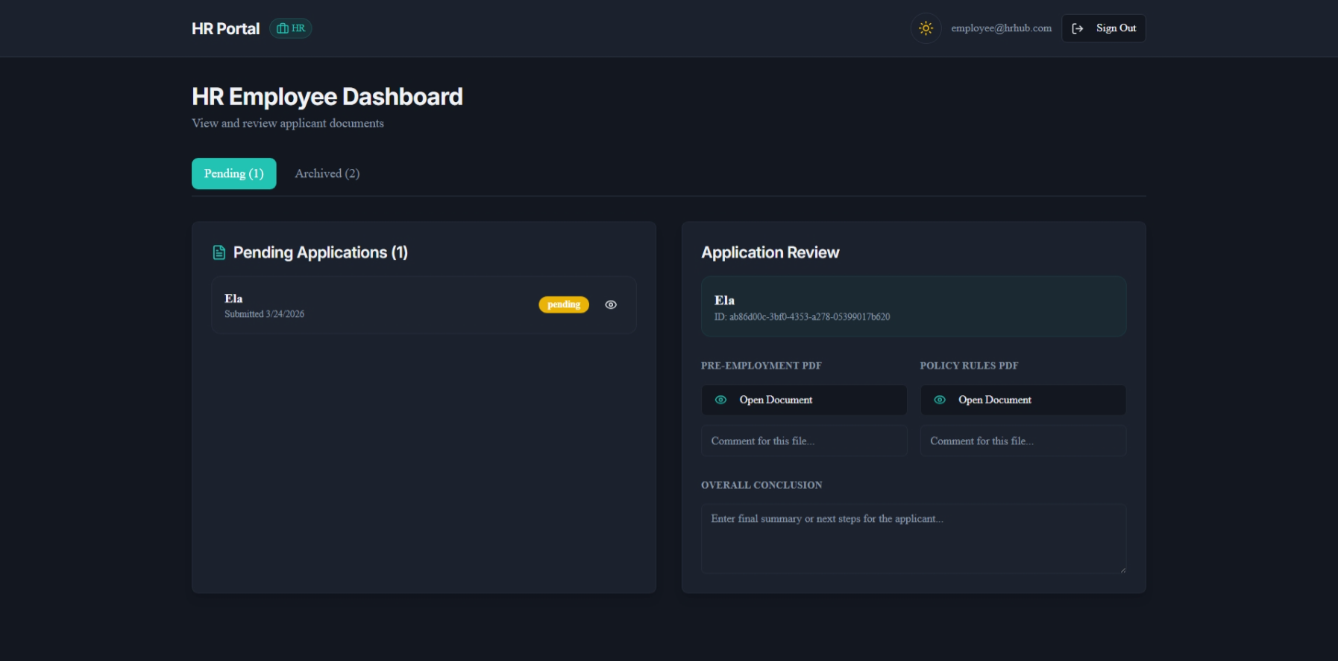
This page displays all pending applications. Here, you can review submitted forms, add comments, and view the overall status.

Archived Applications:
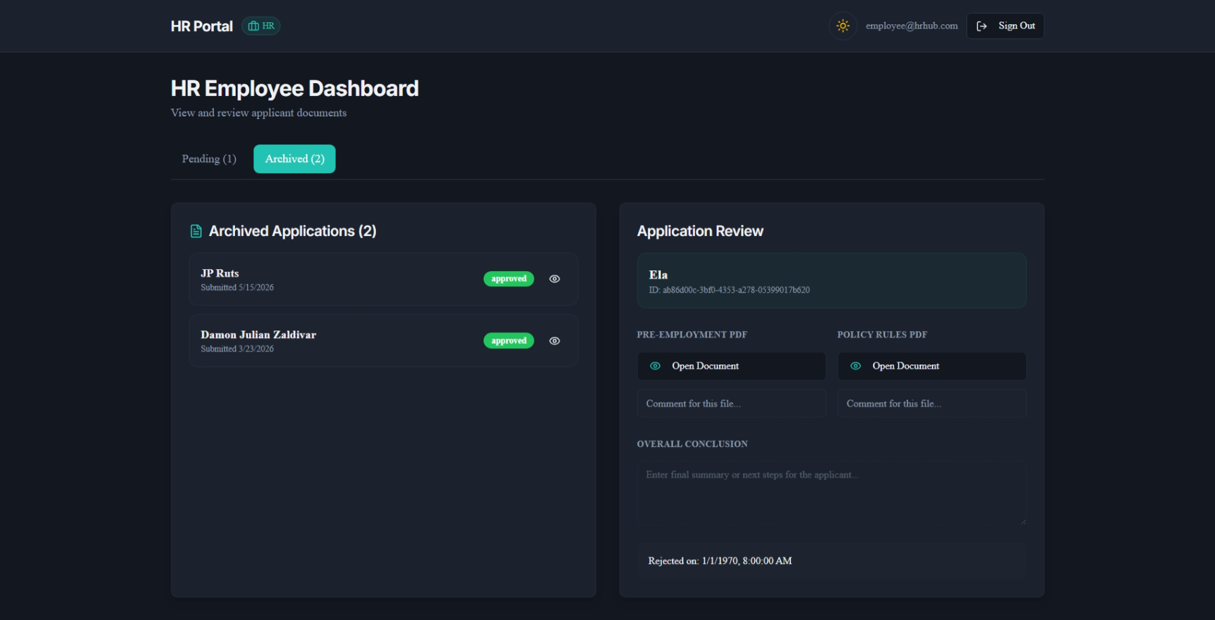
This page displays all pending applications. Here, you can review submitted forms, add comments, and view the overall status.

